AAPS

Billing Platform

Submitted in partial fulfillment of the requirements of

**Mini Project (CSM301)**

for

Second Year of Computer Engineering

By

Adil Khan 21102B0039

Atharva Ingole 21102B0012

Pradip Garhwal 21102B0010

Shivam Mahadik 21102B0003

Under the Guidance of

Prof. Amit Aylani

Department of Computer Engineering

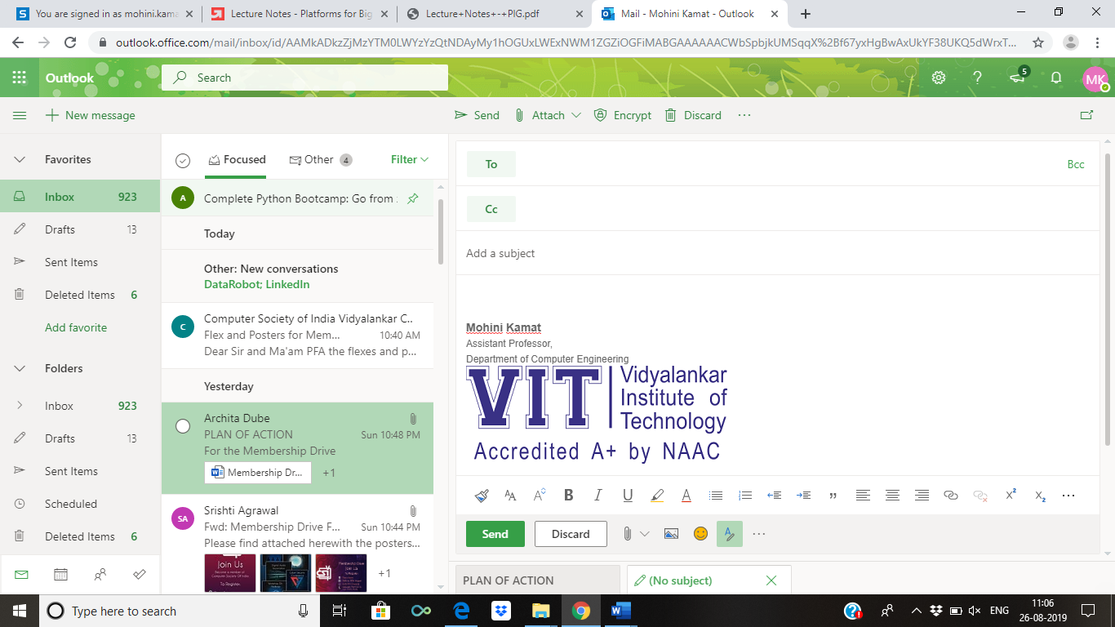

**(An Autonomous Institute Affiliated to University of Mumbai)**

Vidyalankar Institute of Technology

Wadala(E), Mumbai-400437

University of Mumbai

2022-23

**CERTIFICATE OF APPROVAL**

This is to certify that the project entitled

**“AAPS”**

is a bonafide work of

**Adil Khan 21102B0039**

**Atharva Ingole 21102B0012**

**Pradip Garhwal 21102B0010**

**Shivam Mahadik 21102B0003**

submitted to the University of Mumbai in partial fulfillment of

**Mini Project (CSM301)**

for

Second Year of Computer Engineering

Prof.Amit Aylani Dr.Sachin Bojewar Dr.Sunil Patekar

Guide Head of Department Principal

Mini Project Report Approval

This project report entitled ***AAPS***  by

1. Adil Khan 21102B0039
2. Atharva Ingole 21102B0012
3. Pradip Garhwal 21102B0010
4. Shivam Mahadik 21102B0003

is approved for Mini Project (CSM301) for Second Year of Computer Engineering.

|  |  |
| --- | --- |
| Internal Examiner | External Examiner |

Date:

Place:

Declaration

I declare that this written submission represents my ideas in my own words and where others' ideas or words have been included, I have adequately cited and referenced the original sources. I also declare that I have adhered to all principles of academic honesty and integrity and have not misrepresented or fabricated or falsified any idea/data/fact/source in my submission. I understand that any violation of the above will be cause for disciplinary action by the Institute and can also evoke penal action from the sources which have thus not been properly cited or from whom proper permission has not been taken when needed.

Name of student Roll No. Signature

1)Adil Khan 21102B0039

2)Atharva Ingole 21102B0012

3)Pradip Garhwal 21102B0010

4)Shivam Mahadik 21102B0003

Date:

Place:

Acknowledgements

This Project wouldn’t have been possible without the support, assistance, and guidance of a number of people whom we would like to express our gratitude to. First, we would like to convey our gratitude and regards to our mentor Prof. **Amit Ayani** for guiding us with his constructive and valuable feedback and for his time and efforts. It was a great privilege to work and study under his guidance.

We would like to extend our heartfelt thanks to our Head of Department, **Dr.Sachin Bojewar** for overseeing this initiative which will in turn provide every Vidyalankar student a distinctive competitive edge over others.

We appreciate everyone who spared time from their busy schedules and participated in the survey. Lastly, we are extremely grateful to all those who have contributed and shared their useful insights throughout the entire process and helped us acquire the right direction during this research project.

Abstract

This project focus on creating a user friendly and powerful billing platform .The objective of our project is to build an all in one billing platform which comes with inventory, accountings ,GST, SMS and email support. Our software facilitate shopkeeper with the features like sale invoice, barcode generator, GST calculator, Bill summary, SMS and email support. Paperless billing is a process that businesses can be get paid quickly and securely without dealing with hassles of paper bills and check payments .

A unique barcode can be generated for each product and billing can be done by scanning that barcode. With the help of this proposed system ,we reduce the billing time and customers can know the exact cost of the products that they purchased before billing.

This proposed system can be implemented in supermarkets, shopping malls for purchasing the products.

**Table of Contents**

|  |  |  |
| --- | --- | --- |
| **Sr No** | **Description** | **Page No** |
| 1 | Introduction | **8** |
| 2 | Problem Definition | **9** |
| 3 | Literature Survey | **10-11** |
| 4 | Conclusion | **12-16** |
| 5 | References | **17** |

**1. Introduction**

We have developed a powerful billing platform . In invoice management system, the system displays all the available invoice records of each company. In addition, the system allows generating invoices in PDF format. There only a user panel in this simple project. In an overview of this web application, the user can proceed with billing management. For this, the user has to enter the company’s name, address, item name, and quantity. After setting up these pieces of information, the user can proceed towards managing items. Here, it contains a number of fields such as item name, quantity, rate, and tax percentage. Then, the system automatically calculates the total bill of the customer and he/she has to enter the received amount with dues .

In our billing platform user will be able to generate sale invoice. The administrator will be allowed to record and bill all the purchased goods, employee details and modify the prices with the aid of a database functions. The goods can be arranged in categories in the database . Software is designed to handle the time and bill tracking as well as keeping customers informed of their purchase of services and goods.

Our billing software comes with the following features :-

* **New Sale Invoice:** shopkeeper can generate and print sale invoice.
* **New Purchase Invoice:** shopkeeper can record bill the all purchase goods.
* **Generate Barcode:** Barcode can be generated and applied to products for quick identification. It makes purchase and billing process easier and quick.
* **GST Calculator:** GST calculator helps you find out net or gross price of your product based on a percentage-based GST. It also gave you division between CGST and SGST.
* **Bill Summary:** It give you summary of all the bills of the day\month\year
* **Dealer Management**: It will help you to keep the track of your dealer or wholesaler. It will store the information of your purchase.
* **SMS and Email support:** Our software comes with built-in Dual Channel SMS and Email Server which helps you in better communication with clients.
* **GSTR Report:** Using our billing software you can generate various GSTR reports like GSTR-1, GSTR-3B as per format prescribed by Government of India.

**Technology used:**

* Front End: HTML, CSS, Bootstrap, JavaScript.
* Back End: JavaScript, PHP, MySQL.

**2. Problem Definition**

Generally, When we shop something from a shop, then we simply ask the shopkeeper for its selling price and then the shopkeeper will look somewhere and tell us. So the point is that its really difficult task for shopkeeper to remember the prices of all the items in his shop, as well as it’s inappropriate for the customers also, because they might think that the price is biased and decided by shopkeeper itself . Making bills is a bigger task than this. Shopkeeper would make pen paper bill which is very time consuming also there are chances of making mistakes in bill making ,And calculating GST is also a task. Maintaining the used bill books is also a big challenge.

Solution to all these problems is A POWERFULL BILLING SOFTWARE which facilitate shopkeeper with the features like sale invoice, barcode generator, GST calculator, Bill summary, SMS and email support.

**3. Literature Survey**

**3.1 Introduction:**

To study the system being built will require us to study and analyze current systems, in order identify the problems and difficulties with existing system. Included major steps involved in this stage to identify needs users and a study current system to verify the problem. Study of current systems are also benefit to know expected performance by the new system in order meet user requirements. also analysis this information that has been collected and evaluated to help us in build our project.

**3.2 Current System:**

It’s time to take a quick look at some top billing software solutions available today. The products on this list are among the cream of the crop of billing and invoice software solutions on the market. Most of them also go beyond simple billing and invoicing as they offer advanced features that help users run their businesses properly.

* [**Freshbooks**](https://comparecamp.com/freshbooks-review-overview-pricing-and-features/)**:**This popular platform streamlines both time-tracking and invoicing processes. It also includes collaboration tools to help team members work together in the system as well. Some of its core features include invoice customization, estimates management, late payment fees management, online payment processing, quick discount creation, sales tax management, offline payment tracking, timers, and team timesheets. Freshbooks also includes a robust reporting module that generates reports for invoice detail, accounts aging, and balance sheets, among others. Furthermore, it integrates with other popular software like PayPal, Basecamp, and MailChimp. Lastly, Freshbooks has mobile apps for both Android and iPhone users to keep your work accessible wherever you go. Paid plans start at $15 per month.
* [**Xero**](https://comparecamp.com/xero-reviews-pros-cons-pricing-leading-accounting-software/)**:**A go-to app for many finance professionals, this is a complete accounting software that goes beyond simple invoicing and billing. It has advanced features for inventory and project management as well as core tools that include bank reconciliation, online accounting, invoicing, multi-currency support, payroll management, orders management, and financial reporting. The solution also has easy-to-understand controls and an intuitive design. Moreover, this mobile-ready platform can integrate seamlessly with other business tools, including Squarespace, Vend, PayPal, and Evernote, among others. Lastly, pricing for Xero’s paid plans starts at a low $9 per month. This includes five invoices and quotes, five bills, and 20 bank transactions. Perfect for a freelance professional business.
* [**QuickBooks**](https://comparecamp.com/quickbooks-review-pricing-pros-cons-features/)**:**Touted as one of the best applications for small businesses, freelance bookkeepers, and startups, this solution provides tools for expense tracking, invoice management, and tax calculation. If your organization is large, you can go for QuickBooks Enterprise instead. However, QuickBooks Online already packs a big punch. Core QuickBooks Online features include modules for estimate creation, invoice management, bill management, banking data synchronization, payment tracking, automated online banking, balance sheet reporting, and profit and loss reporting. Moreover, the system has open API tools so it can integrate seamlessly with other online solutions like Mavenlink, Jobber, and Method CRM. As for pricing, paid plans start for as low as $10 per month.
* [**Wave**](https://comparecamp.com/wave-review-pricing-pros-cons-features/)**:** Another accounting platform for small businesses, this combines invoicing management, receipt scanning, and accounting capabilities in one comprehensive feature stack. It is perfect for firms with 10 or fewer employees, making it ideal for freelancers, entrepreneurs, and business consultants as well. Core features include invoicing, payroll management, accounting, receipt management, yearly record keeping, direct deposit processing, and tax management. This intuitive and easy-to-use platform also works seamlessly with other digital systems, such as Etsy, PayPal, HubSpot, and MailChimp, among many others. Lastly, it has free packages for its accounting, invoicing, and receipt scanning modules and paid plans that start at $20 a month.
* [**Zoho Invoice**](https://comparecamp.com/zoho-invoice-review-pricing-pros-cons-features/)**:**A comprehensive finance and accounting solution with tools for invoice management, multi-currency support, client portals, partial payment processing, and time tracking. It also has a robust reporting module that lets you generate highly-visual and easily-understandable reports. In addition, it comes with a calendar view for timesheets for easier invoice creation. What’s more, Zoho works perfectly with other Zoho products so you can extend its functionalities seamlessly. Last but not least, this mobile-ready platform can work well with other business systems. The long list includes Google Drive, OneDrive, Braintree, and Clockodo, among others. For those interested, Zoho Invoice has a free version available. If you have a larger team that requires more sophisticated features, the pricing for paid plans starts at $9 per organization per month.

**4. Conclusion**

AAPS is billing platform developed using following technologies

* Front End: HTML, CSS, Bootstrap, JavaScript
* Back End: JavaScript, PHP, MySQL

With the following features working :-

* New Sale Invoice: shopkeeper can generate and print sale invoice.
* New Purchase Invoice: shopkeeper can record bill the all purchase goods.
* Generate Barcode: Barcode can be generated and applied to products for quick identification. It makes purchase and billing process easier and quick.
* GST Calculator: GST calculator helps you find out net or gross price of your product based on a percentage-based GST. It also gave you division between CGST and SGST.

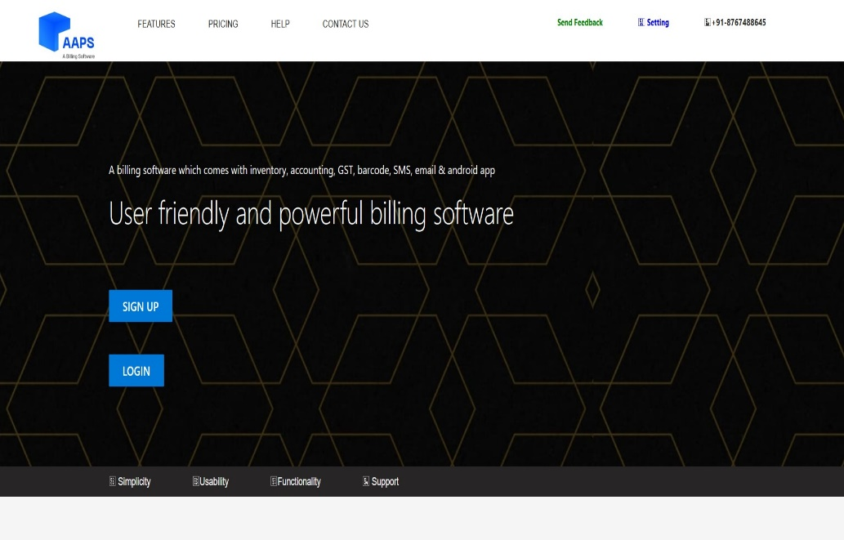

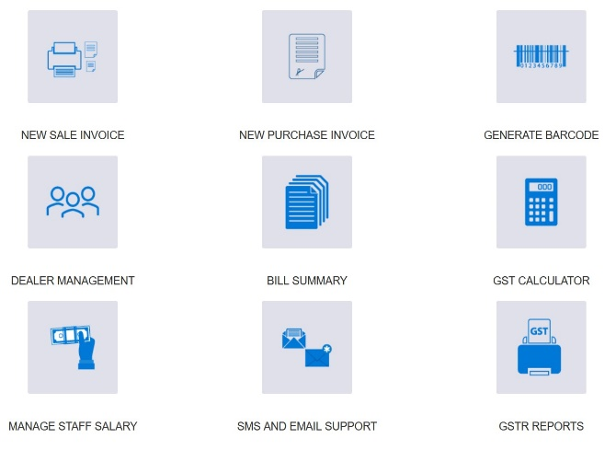

Menu

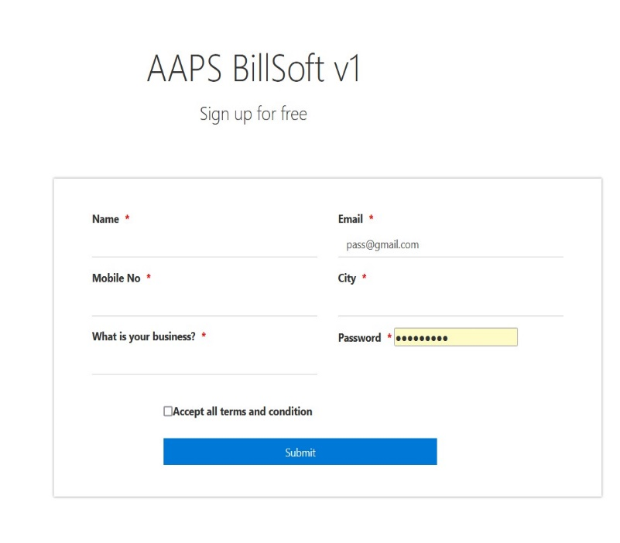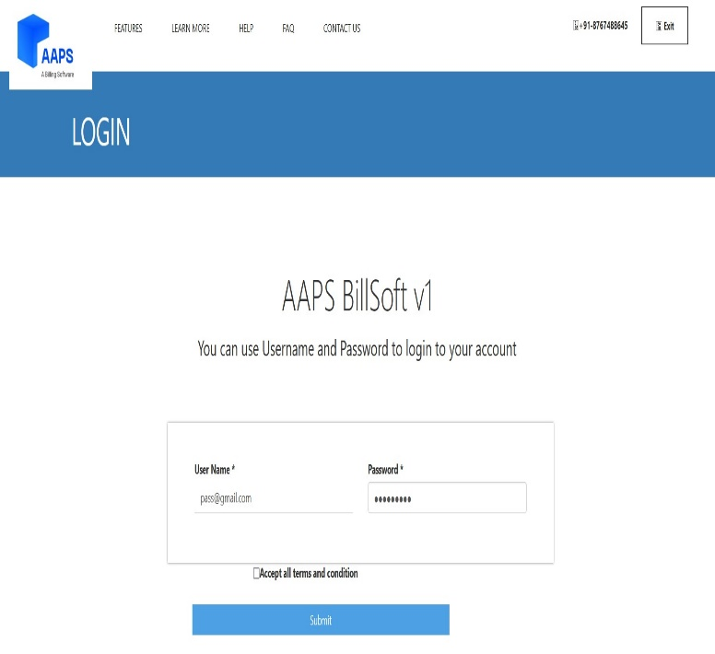

Signup

Login

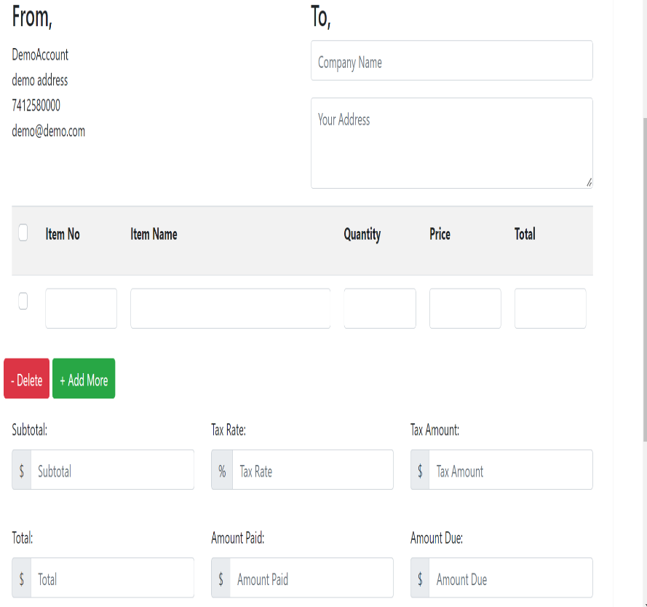

New Sale Invoice

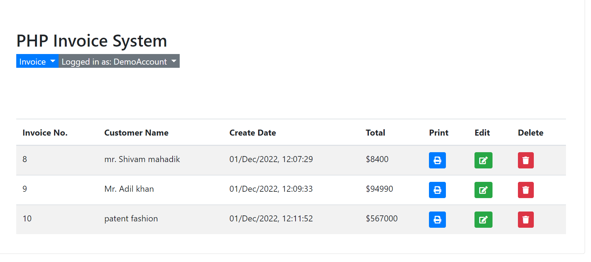

Invoice List

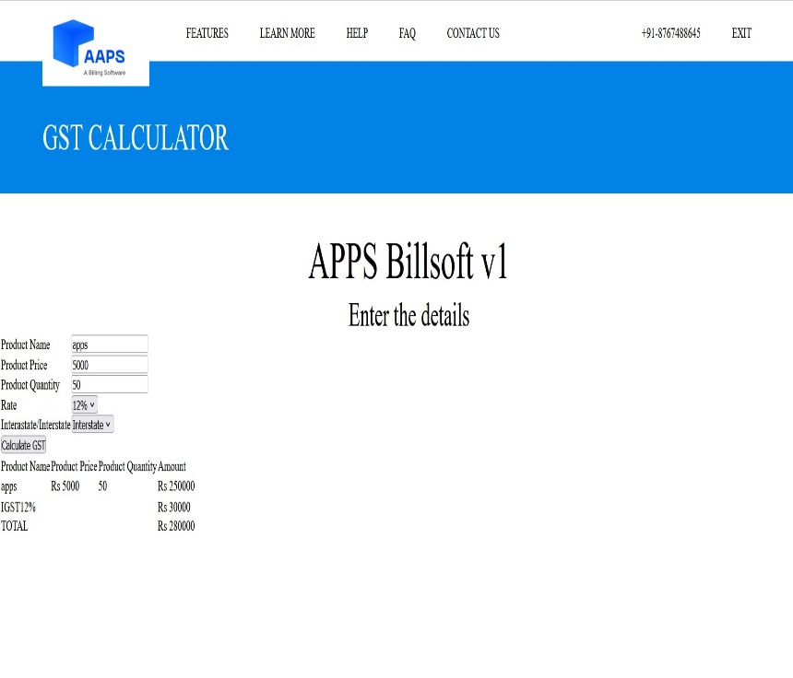

GST Calculator

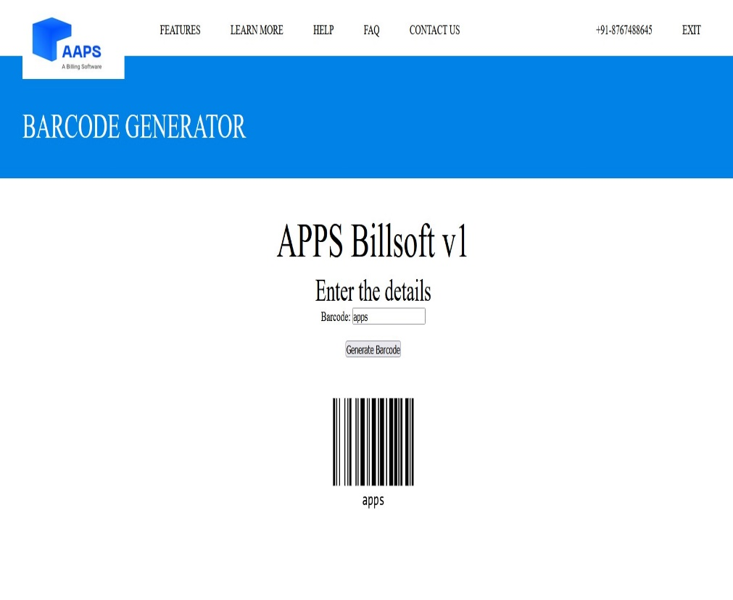

Barcode

Generator

**Future scope:**

There is always a room for improvements in any software. Right Now we just have 4 features working. In future we may be extended to include features such as:

* Bill Summary: It give you summary of all the bills of the day\month\year
* Dealer Management: It will help you to keep the track of your dealer or wholesaler. It will store the information of your purchase.
* SMS and Email support: Our software comes with built-in Dual Channel SMS and Email Server which helps you in better communication with clients.
* GSTR Report: Using our billing software you can generate various GSTR reports like GSTR-1, GSTR-3B as per format prescribed by Government of India.
* Mobile app

**5.Reference**

1. <https://financesonline.com/top-10-billing-software-systems#:~:text=10%20Best%20Billing%20Software%20Systems%201%201.%20Melio,5.%20FreshBooks%20...%206%206.%20Salesforce%20CPQ%20>
2. Hitech billing software <https://billingsoftwareindia.in/>
3. Sappy billing software <https://sappytech.com/software.php>
4. Vyapar <https://vyaparapp.in/easy-billing-software?campaign_id=BINGSBS38&campaign_id=DSA-BINGS&msclkid=59acc91dfeff165bff39aa9c3823cbac&utm_source=bing&utm_medium=cpc&utm_campaign=7.3Vyapar_(DSA-BINGS)_13th_Oct&utm_term=https%3A%2F%2Fvyaparapp.in%2Feasy-billing-software%3Fcampaign_id%3DBINGSBS38&utm_content=BINGS>
5. Zoho <https://www.zoho.com/in/books/?utm_source=bingads&utm_medium=cpc&utm_campaign=Zoho%20Books%20Search%20IND&utm_content=Accounting%20Software&utm_term=accounting%20billing%20software&device=c&network=o&creative=81089057430431&matchtype=p&searchterm=sappy%20billing%20software&msclkid=db1370197f661c25795f1398b9ba444c>